Joseph Stabach
Geogebra Lesson: Perpendicular lines
Grades 7-10

1) Launch Geogebra.

2) Click on the graphics tab at the top left and choose Show Grid.

3. Create a line. Click the line tool and plot two points on the graph: A (-2,4) & B (2,2) to give us line (a) x+2y=6

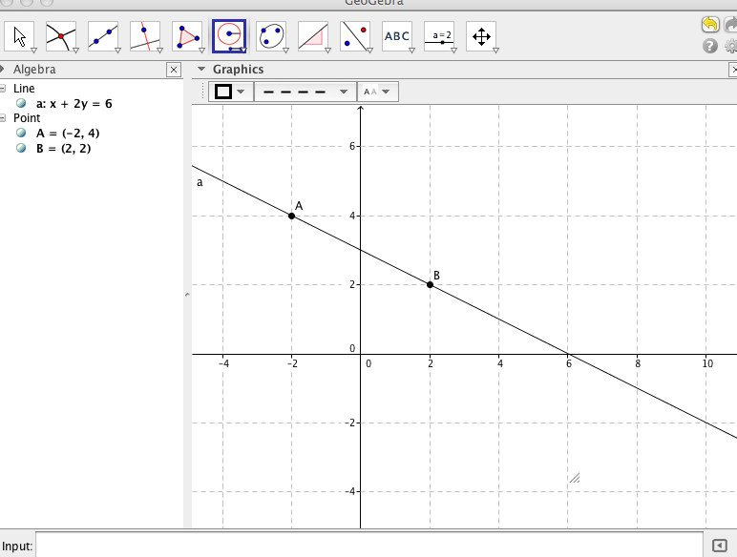
4. Click on the compass tool (6th tab across). Now click point A and then click point B to make A the midpoint of CB. Plot the circle so the center of the circle is point A.

5. Click on the intersection tool (2nd tab across) and mark the point where the circle first meets line (a). This point will be called C. Click the move tool (1st tab across) then click on the circle and change the color of the circle to red. Point A is now the midpoint of CB. We must now bisect CB by creating a 4th point more than halfway between CB.

6.Click the point tool (2nd tab) and plot a point D, relatively close to point A. Hide this point by clicking the move tool then clicking on the point and clicking- label style: hidden.

We now need to create two circles. Both with the size of radius from C to D, with one circle having a center of C and one with a center of D.

7. Click on the compass tool then click on both points C and D, creating a circle. Click the move tool and move the circle so that the center is point C. Repeat this process step-by-step except this time drag the circle so the center is point D. After creating the circles, right click each circle and color them blue.

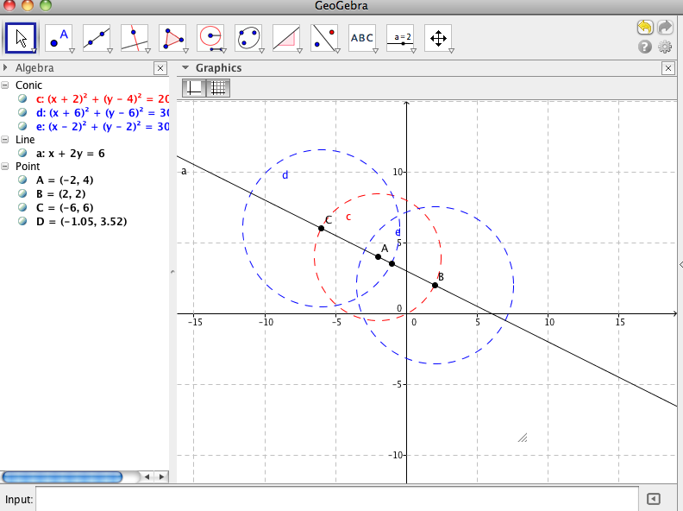

8. Click the intersect tool (2nd tab) and plot point E where the blue circles intersect slightly above point A. [ Make sure both blue lines are highlighted before plotting the point ]
9. Click the line tool (3rd tab) and plot a line that goes through points E and A. Color this line green.

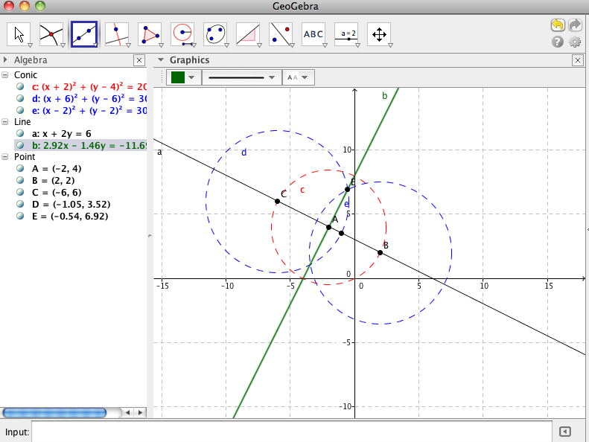

Check our construction:

What happens when we move point A?

______________________________________________________________________________________________

What happens when we move point B?

_______________________________________________________________________________________________

Create perpendicular lines following the above guidelines using the points: A (-1, 3) and B (2, 5). What do you notice about the slope of these lines?

