Penny Boat Challenge

Name: _________________________________________________________________________

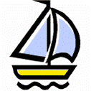
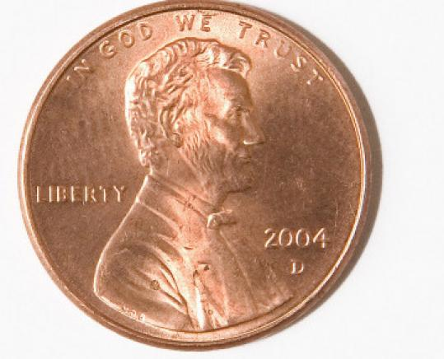

Anyone that has ever lifted an object out of water has noticed that the object gets heavier as more of the object is lifted above the surface of the water. The reason for this effect is that the water is exerting an upward force upon the object. This upward force is called the buoyant force. So, when the weight of an object is greater than the water’s buoyant force, the object sinks. When the weight is less than the buoyant force, the object floats, and when the weight and buoyant force are equal, the object will remain at any level in the water. Fish are a familiar example of this last characteristic. Therefore, the greater the surface area of the object being placed in water, the more buoyant force it has being applied to it to help it float.

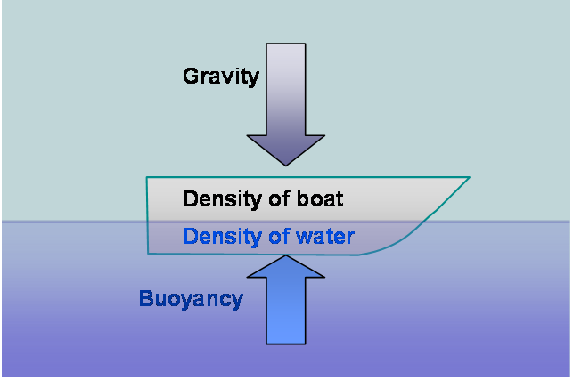

Goals: Design a boat out of aluminum foil that will hold the most number of pennies and still stay afloat.

Objectives: Determine whether the surface area of the aluminum foil boat affects its buoyancy.

Materials: roll of aluminum foil, pennies, container, and tap water.

Procedure:
1. Get into groups of 4 or 5
2. Each group gets 40 pennies and a container of water.
3. Each student gets a 12in. by 18in. square of aluminum foil, so you will have 4 or 5 trials as a team to design a boat that holds the most pennies.
4. Use your foil to construct a boat that you think will hold the most pennies without sinking. Each boat can ONLY be used ONE time. Once your boat sinks, you are out.
5. You may fold your foil and create your boat dimensions any length you want.
5. Begin testing the number of pennies that each boat can hold by putting in one penny at a time.
6. The boat must remain floating for 5 seconds before it is considered a successfully added penny. After 5 seconds, you may then add another penny.
7. If water enters the boat, or your boat touches the bottom of the container, your boat is “sunk.” The last penny added (that sunk the boat) will not count in the total amount held.
8. As a group, discuss the pros and cons of each of your boat designs. Look at the boat that held the most pennies before sinking, and discuss what made that boat better than the other boats. (Also, consider the flaws you want to avoid in your new boat design.)

If two objects are the same size and shape but have different weights, the heavier object will sink lower into the water until it has achieved equilibrium.

Boats take advantage of this buoyant principle because, even though a ship may be incredibly large and heavy, it is not as heavy as the volume of water it displaces.
All boats, but cargo ships in particular, have a maximum allowable load that they can carry and still remain stable and afloat.
The goal of this lesson is to demonstrate this principle, and for students to figure out a boat design that can carry the heaviest amount of cargo.

Pre- Boat Build

- Predict how many pennies your boat will hold: ________________

- Each penny weighs 2.5 grams. How many grams will your boat hold if your prediction comes true? ________________________

- What strategy will you be using when building the dimensions of your boat?

_______________________________________________________

_______________________________________________________

_______________________________________________________

Analyzing Data

How many pennies did your boat hold? __________________

Was that amount more or less than your prediction? __________________

Would you change the design of your boat if you did this activity over again? If so what would you change? If not, what would you leave the same?

_______________________________________________________

_______________________________________________________

_______________________________________________________

_______________________________________________________

_______________________________________________________

